

CSA0501-DATABASE MANAGEMENT SYSTEMS

LAB EXPERIMENTS DATE: 10/07/2026

EXPERIMENT 1 -- DDL Commands (PRIMARY, FOREIGN KEY, UNIQUE, CHECK)

AIM: To implement and demonstrate the use of DDL commands with constraints such as PRIMARY KEY, FOREIGN KEY, UNIQUE, and CHECK constraints on the student_cgpa_details table using MySQL.

PROCEDURE:
- Select the required database using the USE command.
- Create the student_cgpa_details table with required attributes.
- Apply PRIMARY KEY constraint on student_id to uniquely identify each student.
- Apply UNIQUE constraint on student_name to avoid duplicate names.
- Apply CHECK constraint on CGPA and semester values to maintain valid data.
- Create a department table and establish a relationship using a FOREIGN KEY constraint.
- Verify the applied constraints using DESC and SHOW CREATE TABLE commands.
- Display the final table details and confirm successful execution.

PROGRAM:
1. TABLE
USE student_cgpa;
SELECT * FROM student_cgpa_details;

OUTPUT:

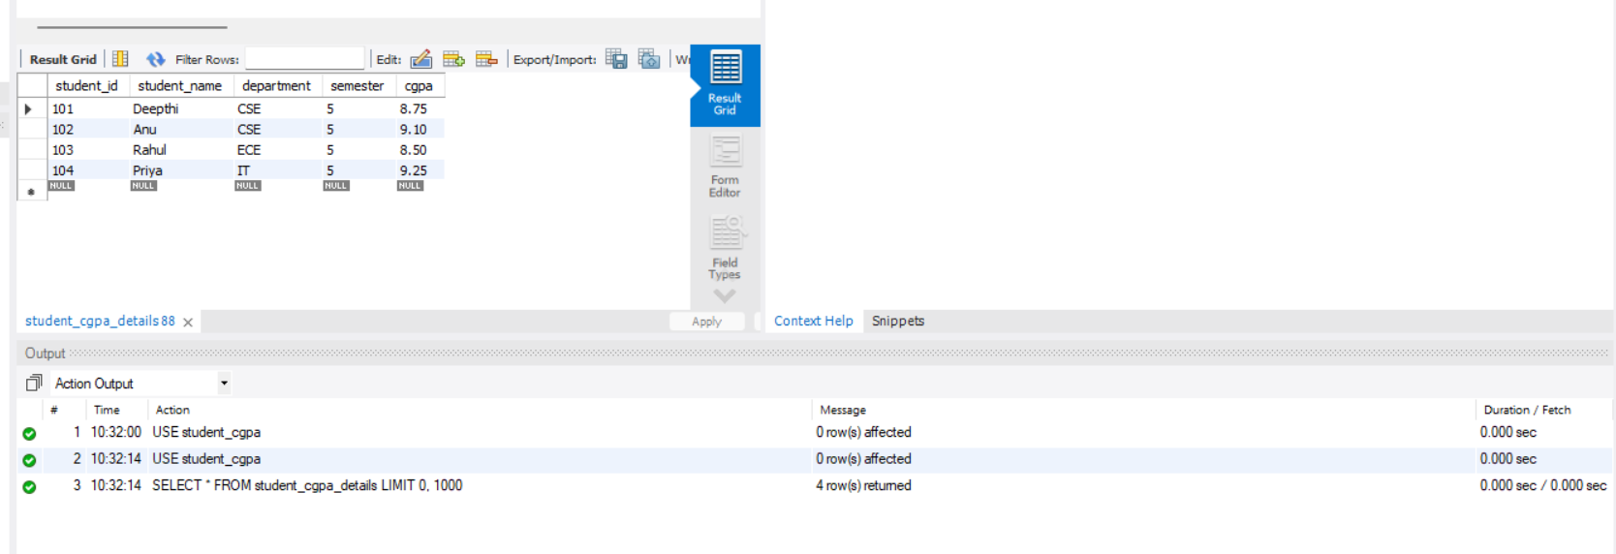
2. PRIMARY KEY

DESC student_cgpa_details;
ALTER TABLE student_cgpa_details
ADD PRIMARY KEY(student_id);

OUTPUT:
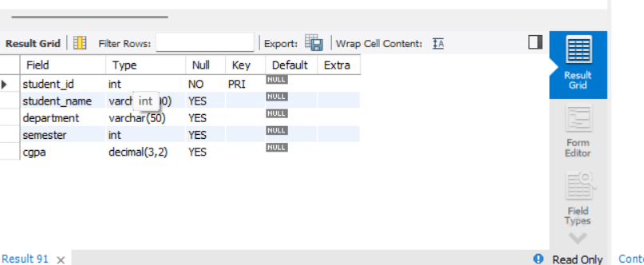

2. UNIQUE KEY:

DESC student_cgpa_details;
ALTER TABLE student_cgpa_details
ADD CONSTRAINT unique_student_name
UNIQUE(student_name);

OUTPUT:

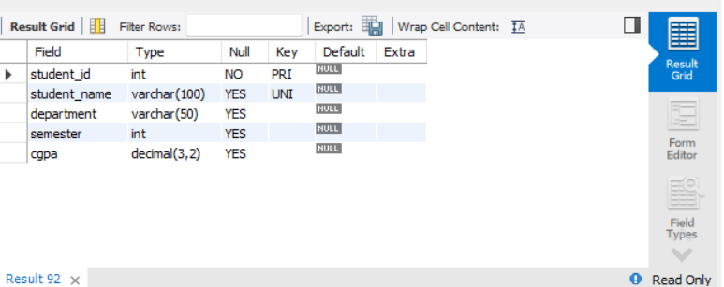

3. CHECK CONSTRAINT:

DESC student_cgpa_details;
ALTER TABLE student_cgpa_details
ADD CONSTRAINT chk_cgpa
CHECK(cgpa >= 0 AND cgpa <= 10);

OUTPUT:

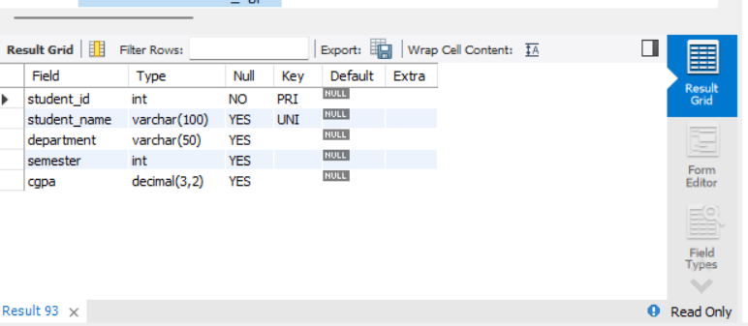

4. FOREIGN KEY CONSTRAINT:

ALTER TABLE student_cgpa_details
ADD CONSTRAINT fk_department
FOREIGN KEY(dept_id)
REFERENCES department_details(dept_id);

OUTPUT:

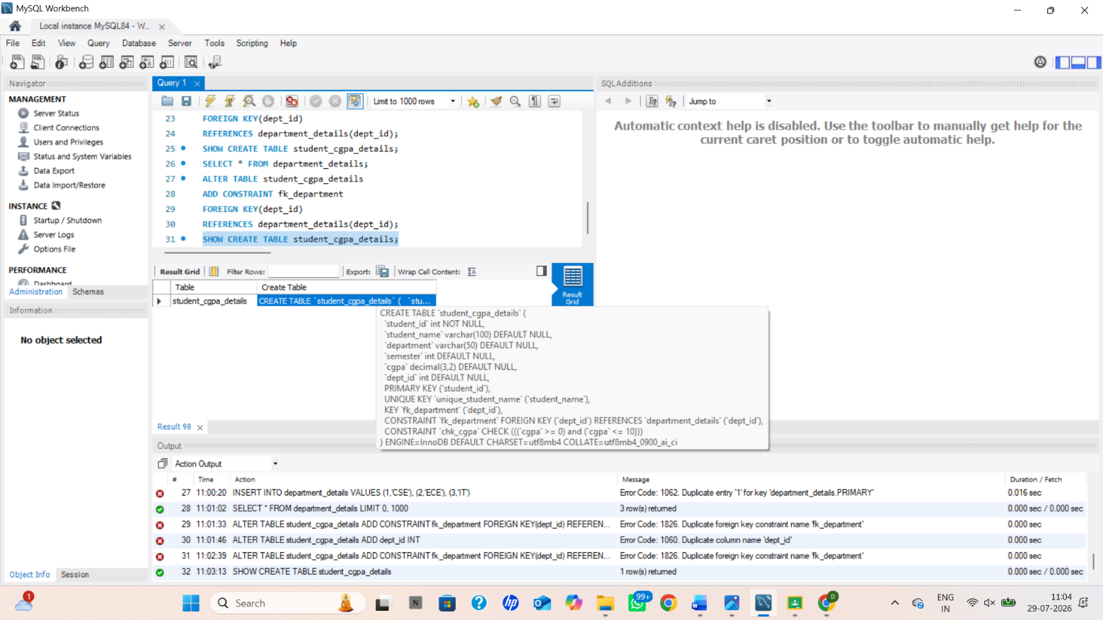

RESULT: DDL Commands with Primary, Foreign, Unique, Check constraints are updated and verified.

